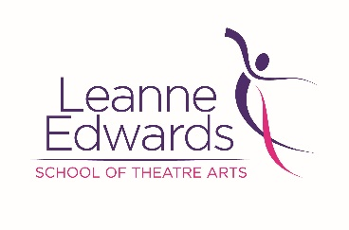
Privacy Policy

Leanne Edwards School of Theatre Arts is committed to protecting your privacy online and we appreciate that you want the personal information you provide to us to be kept private. Here we explain how we collect information through the web site, what we do with it and what controls you have.

What data do we collect?
So that we can provide you with services and respond to your email/enquiry form requests, we ask you to submit information such as your name and contact details. You are under no obligation to provide such information. However, if you should choose to withhold requested information, we may not be able to contact you.

How is the information used?
We will use the information you provide to us to arrange services requested by you and respond to any enquiry. If you have e-mailed us we will use your e-mail address to respond to your query.

Once we have provided your services or responded to your enquiry your details may be kept on our system to ensure that we can contact you if the need arises in the future.

Under no circumstances will we share your information with any other third parties whatsoever unless you have asked us to or we have otherwise agreed this with you first.

With whom else is the information shared?
We may disclose personal information if required to do so by law or if we believe that such action is necessary to protect and defend the rights, property or personal safety of Leanne Edwards School of Theatre Art’s website or its visitors.

This website may contain links to other websites. Leanne Edwards School of Theatre Arts is not responsible for the privacy policies or the content of such web sites.

Security
Leanne Edwards School of Theatre Arts places a great importance on the security of all personally identifiable information associated with our contacts and consequently we take reasonable precautions to protect against the loss, misuse and alteration of contact data under our control.

Use of cookies
This web site may use cookies or other devices to automatically collect personal information about visitors to the site. This information is limited to the IP address of the computer you are using to access the site. This information is used solely for admin purposes to monitor levels of usage of the web site.

Where is the information stored?
All information which you submit via this website is sent to and stored on a computer located in the United Kingdom. This is necessary in order to process the information and to send you the information you have requested.

Your acceptance of these terms
By using the Leanne Edwards School of Theatre Arts website, you consent to the collection and use of your information by Leanne Edwards School of Theatre Arts as set out in this privacy policy. If we change our privacy policy in any way, we will post these changes on this page.

Your rights
You have a legal right to a copy of all the personal information about you held by us. You also have a right to correct any errors in that information. You have a right to ask us to stop sending you direct marketing material at any time even if you have previously asked us to do so or have otherwise agreed to this.

Please contact us with any questions, concerns or comments you have about our Privacy Policy.

